History of Women
Student’s Name
Institutional Affiliation

American Women History (political equality)
- Primary source- Portraits of Revolutionary women (unit 1)
- Primary Source – Elizabeth Cady Stanton, Declaration of Sentiments (1848) (unit)
- Primary source- Progressive women and Political Parties (unit 3)
Introduction
Women have undergone many milestones in terms of political equality in the United States. Political equality for women has gone through significant steps, and it has taken the effort of many women who sought to seek for political equality. This paper uses three primary sources to show political balance in the history of men in America for unit 1, 2 and 3. The primary source for unit one is Portraits of Revolutionary women, for unit two was “Elizabeth Cady Stanton, Declaration of Sentiments (1848)” while for unit three is “Progressive women and Political Parties.” The paper also shows some images of the primary sources in the history of women as far as political equality is concerned.
Portraits of Revolutionary women
Portraiture flourished in America in the 18th century. The enthusiasm fir portraiture produced many images of women, many women were prominent in the revolutionary era. The portrait by John Singleton Copley in 1763 emphasizes her femininity. The portraits of revolutionary women show the journey of women in politics.

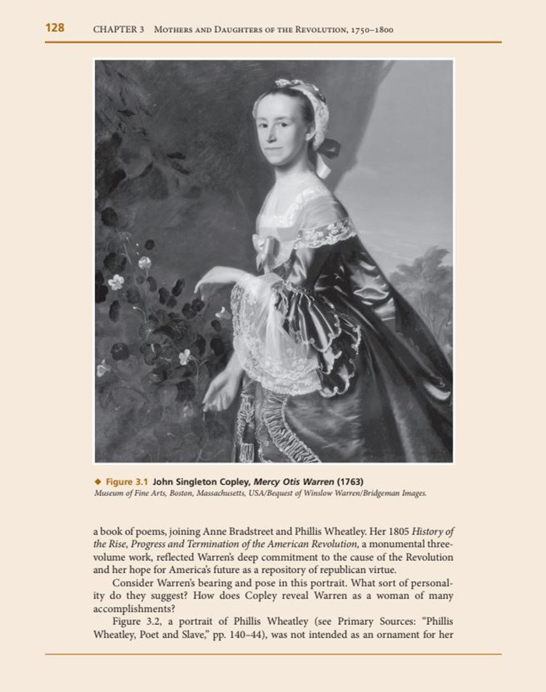
Elizabeth Cady Stanton, Declaration of Sentiments (1848)
This is one of the primary sources which shows the political history of women in America. It is the report of the women's rights convention, which was held at Seneca Falls, New York on July 19th and 20th, 1848. Elizabeth Candy Stanton convened the assembly. It was the first women's convention organized by women. The convention held that all men and women are created equal, and their creator endows them with certain inalienable rights, which include life, liberty, and the pursuit of happiness. To secure these rights, governments are instituted, deriving their just powers from the consent of the governed. Whenever the government destroys these ends, those who suffer have the right to refuse allegiance to it and to insist on the institution of a new government. The statement in the convention showed that women were dissatisfied with the government of the time and that they were demanding the equal station to which they were entitled. The convention stated that the history of humanity is a history of repeated injuries and usurpations on the part of women towards women. The facts to prove this included that man has never permitted a woman to exercise her inalienable right to the elective franchise. Secondly, man has compelled the woman to submit to laws in a form in which she is voiceless. Thirdly, men have been forcing women to submit to rules which are given to the most ignorant and degraded men. By denying the women the right of a citizen, the elective franchise, man has left her with no representation in the halls of legislation.
The convention highlighted other oppressions that women faced at the moment. They included being sidelined in church affairs, the right to own property, monopoly of all profitable employment, rights of marriage, educational rights. Due to the above inequalities, women felt aggrieved, oppressed and fraudulently deprived of their most sacred rights. The convention advocated for direct admission to all rights and privileges that belonged to them as US citizens. Women promised to employ agents, petition the state and national legislatures and, circulate tracts. Generally, the convention showed how the US government had oppressed women by not granting them equal rights that men of all caliber enjoyed. This primary source is significant because it led to a Declaration of Sentiments modelled on the Declaration of independence. The Declaration demanded a variety of rights for women, including suffrage. The convention was the starting point for the long journey for the fight of rights of women because 18 years later, the leader of the convention Elizabeth Cady Stanton, became the first woman to run for the United States House of Representatives despite being ineligible to vote.

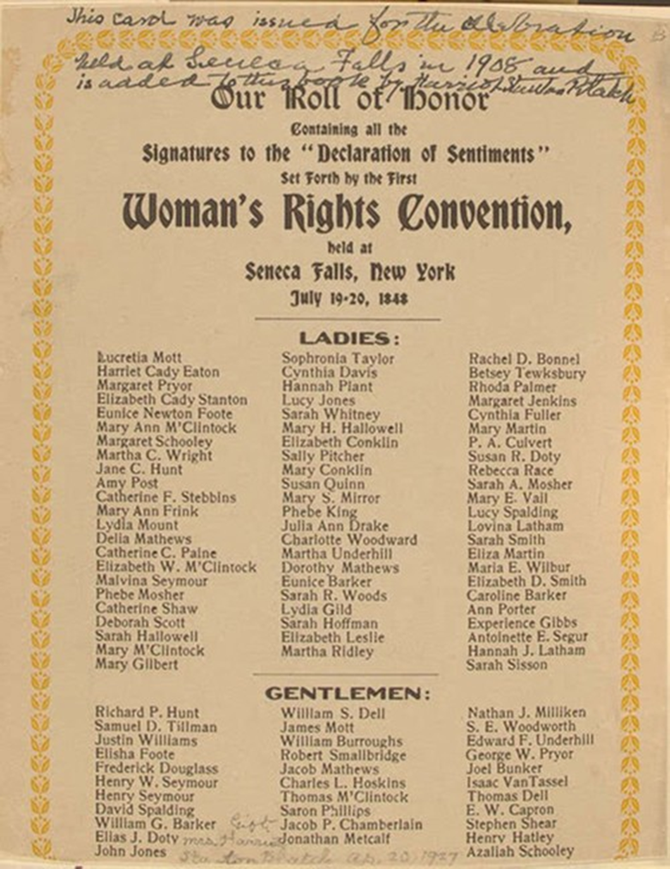

Progressive women and Political Parties
This primary source shows the role of women in politics in 1912. According to the source, many female reform activists were drawn to the traditionally male arena despite the rhetoric of maternalism. Women involved themselves in the 1912 election anticipating that their voting rights were over the horizon. Women tended to be nonpartisans and put the issues and candidates above party loyalty. They could however be found in the ranks of all prominent parties. Many women who were active in politics were found in the reform wing of the Republican Party. In 1912, Theodore Roosevelt (reformer’s candidate) lost the Republican Party nomination to the William Howard Taft who was the incumbent which made the reformers to bolt the party and create the independent Progressive Party. The progressive party supported women suffrage and integrated women to its affairs. Jane Addams, the leader of the women reformers was chosen to second Roosevelt’s nomination as the presidential candidate of the party. The presidential election of 1912 featured strong Eugene Debs, a sociologist candidate. Both progressive and socialist parties advocated for women suffrage and minimum wage laws for women. However, the ultimate goal of the socialist was to work class empowerment while the Progressive sought for interclass harmony. Roosevelt received more popular votes than President William Howard Taft in the 1912 election. History was made when Debs won only won 6% of the presidential vote but socialists were elected to state and local offices and even to Congress which marked the high point of electoral socialism in the history of America. This was a great milestone in the history of women in the politics of America.

Conclusion
In summary, this paper has discussed the history of political equality of women in the United States using three primary sources. The primary sources are Elizabeth Cady Stanton, Declaration of Sentiments (1848), Portraits of Revolutionary women, and Progressive women and Political Parties. These sources are used to show the milestones that women have strived to achieve. The paper shows how women have fought for political equality and other rights throughout history, starting from voting rights to being elected to Congress and finally vying for a presidential election. This calls for respect for women because they have demonstrated their ability in terms of politics and other affairs. Political equality should be embraced for both men and women in the 21st century.

References
Ford, L. (1991). Iron-jawed angels: the suffrage militancy of the National Woman's Party, 1912-1920. Univ Pr of Amer.
Stanton, E. C. (2000). Declaration of Sentiments (1848). Women’s America, 207-209.

